**Logging Level handler with Actuator**

1. Setting logging level to “**INFO**”

POST URL: <http://localhost:8080/loggers/ROOT>

Data:

|  |
| --- |
| {  "configuredLevel": "INFO",  "effectiveLevel": "INFO"  } |

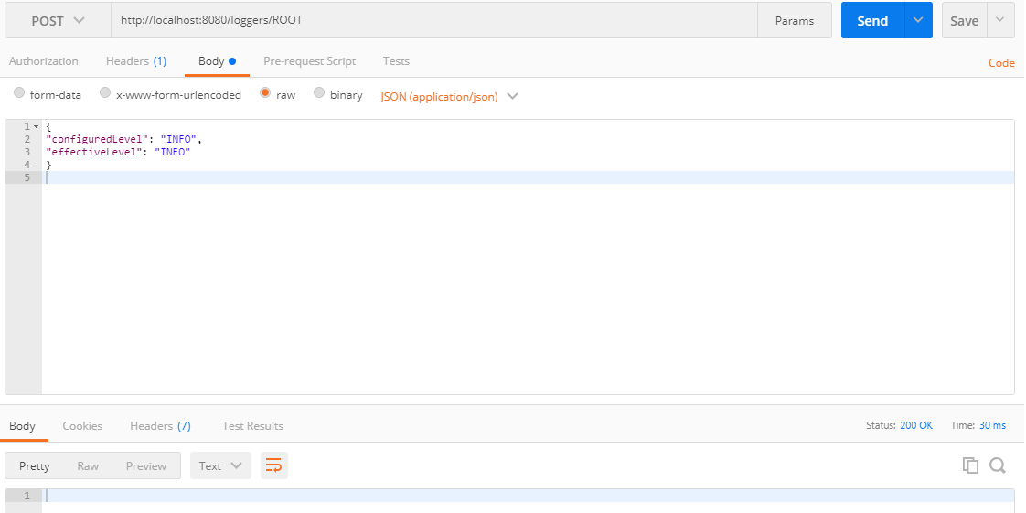

Only **INFO** logger are visible

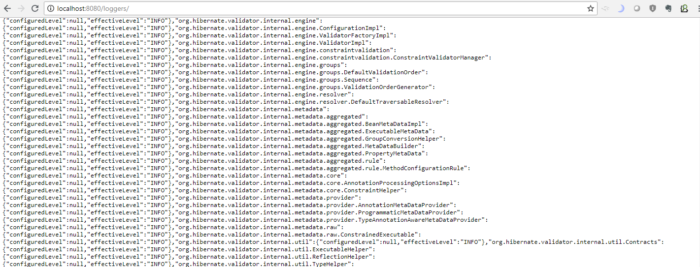

1. Setting logging level to “**WARN**”

POST URL : <http://localhost:8080/loggers/ROOT>

Data:

|  |
| --- |
| {  "configuredLevel": "WARN",  "effectiveLevel": "WARN"  } |

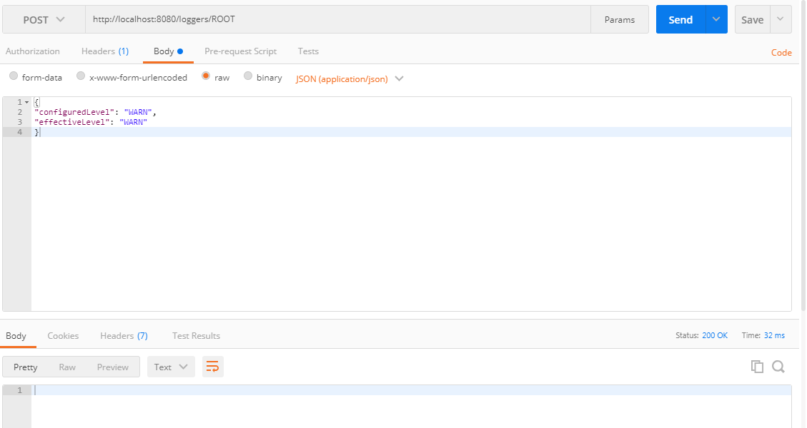

Only WARN logger are visible

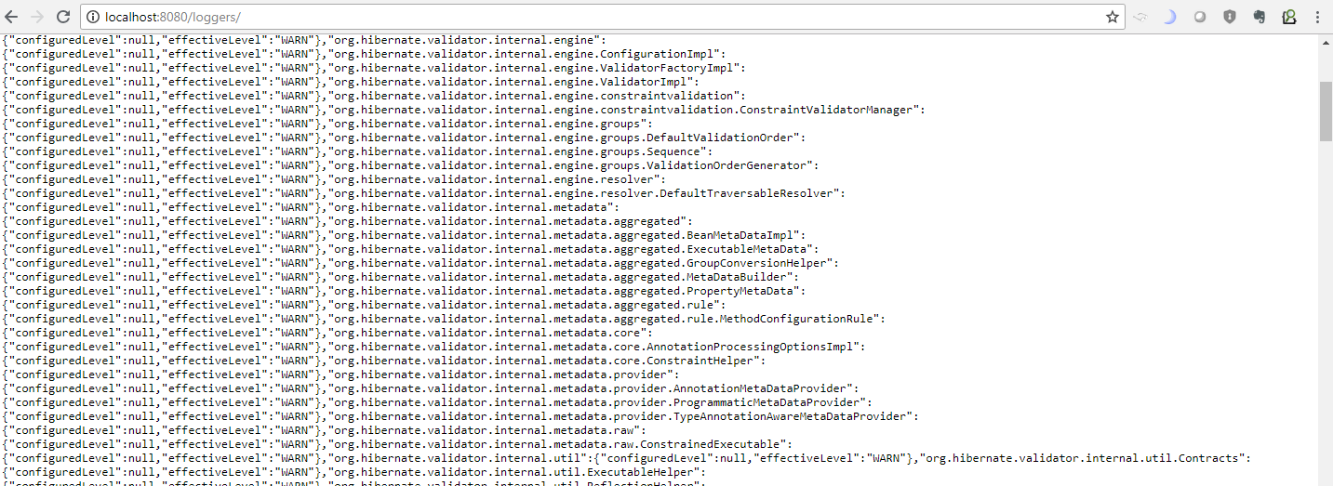

1. Setting logging level to “**ERROR**”

POST URL : <http://localhost:8080/loggers/ROOT>

Data:

|  |
| --- |
| {  "configuredLevel": "ERROR",  "effectiveLevel": "ERROR"  } |

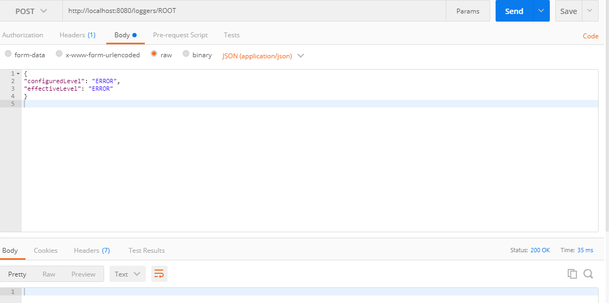

Only WARN logger are visible

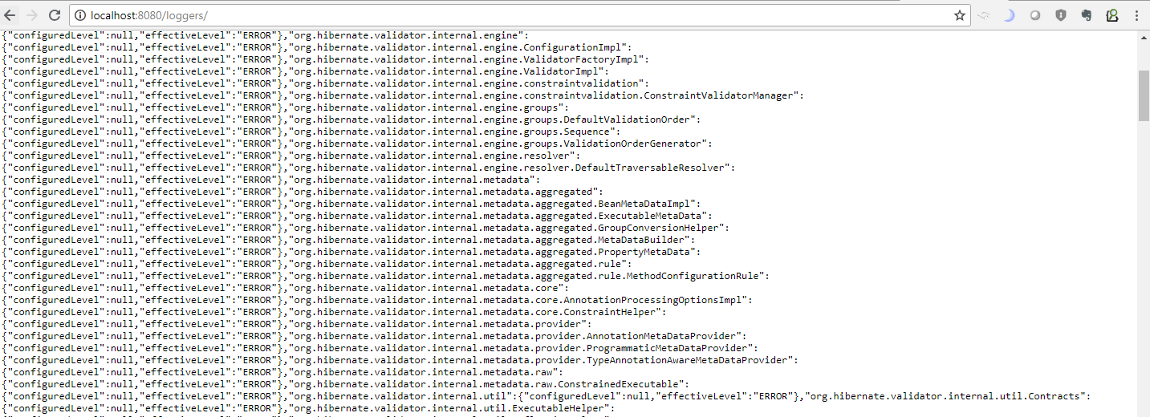

1. Setting logging level to “**DEBUG**”

POST URL : <http://localhost:8080/loggers/ROOT>

Data:

|  |
| --- |
| {  "configuredLevel": "DEBUG",  "effectiveLevel": " DEBUG "  } |

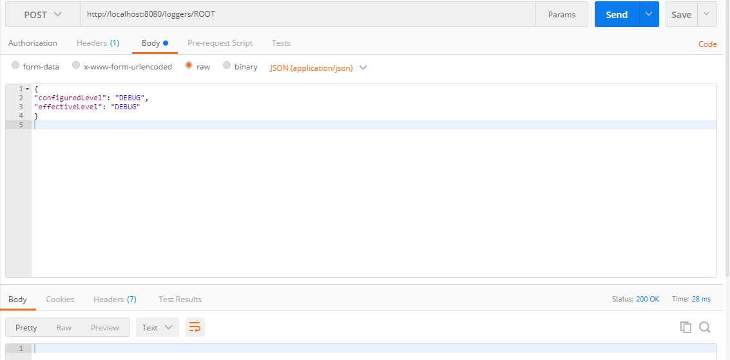

Only WARN logger are visible

